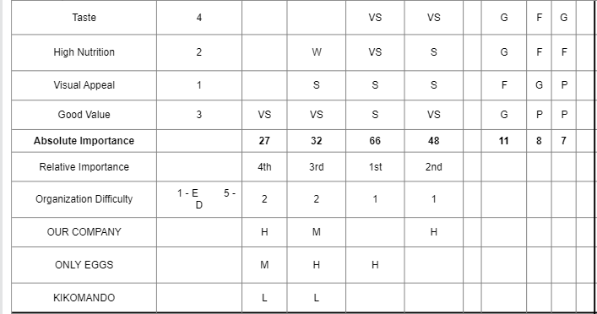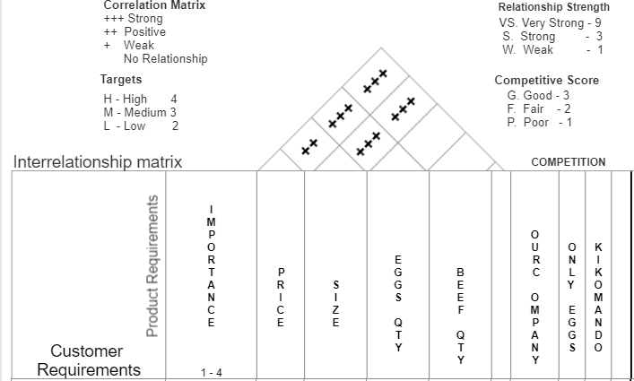HOUSE OF QUALITY REPESENTATION FOR A BEEFED ROLAX

What are we doing with the house of quality?

**The roof Section**

At the top of HOQ, this looks at the technical correlation metrix of the technical requirements.

These are product requirements of “Beefed Rolex” and that is Price, Size, Eggs quantity and Beef Quantity. This also has a scale that represents how our products are correlated from the customer’s view.

**Customer Requirements Section**

In this section of the HOQ we record the customer’s wants or preferences of the beefed rolex and their relationship to the product is correlated using the interrelationship metrix

**Planning Metrix Section**

Here we look at the competitors of our product i.e. “Only Eggs” and “Kikomando” products. We are use planning metrix to relate what the beefed customers want and how our company is going to fulfill them. We further look at the customer’s voice basically what they have to say about our product in relation to our competitors.

**The steps involved in constructing the HOQ**

1. Recording voice of the customer(their wants or needs)
2. Ranking the importance of the requirements
3. Translate customer wants into the technical descriptors or the How’s of the technical needs. How are the engineers going to design a product that will meet the customer needs?
4. Examine relationships between design between design and the customer requirements
5. Ranking what is important in terms of Design
6. Look at relationships in design requirement themselves
7. Customer rating of competitors(their perception of us to our product)
8. Organizational difficulties on delivering required product.
9. Recording targets with technical evaluation of the competitors.

**The Customer Requirements**

These are derived from the surveys conducted on the customers of the product and in our case we assume that these are the most pressing customer needs i.e. Taste, High Nutrition, Visual Appeal and Good Value. These are ranked according to how they were important to the customer during the customer surveys. The